(HONORS) GEOMETRY NAME: _______________________
Unit 6 Lesson 2 - Properties of Parallelograms BLK: ___ DATE: _______________

Parallelogram:

Theorem:
If a quadrilateral is a parallelogram, then both pairs of ___________ sides are ______________.

Theorem:
If a quadrilateral is a parallelogram, then both pairs of ___________ angles are _____________.

Theorem:
If a quadrilateral is a parallelogram, then both pairs of ___________ angles are _____________.

Theorem:
If a quadrilateral is a parallelogram, then both diagonals _______________ each other.

1. Find the value of each variable in the parallelogram.
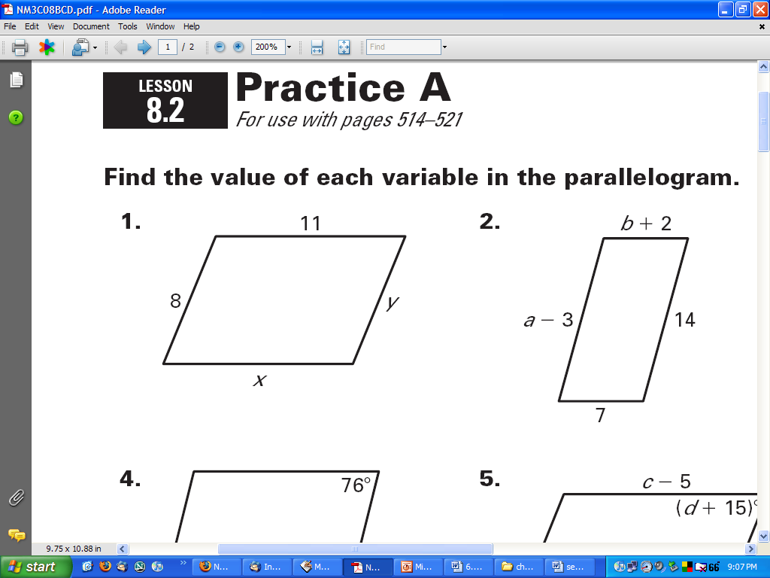

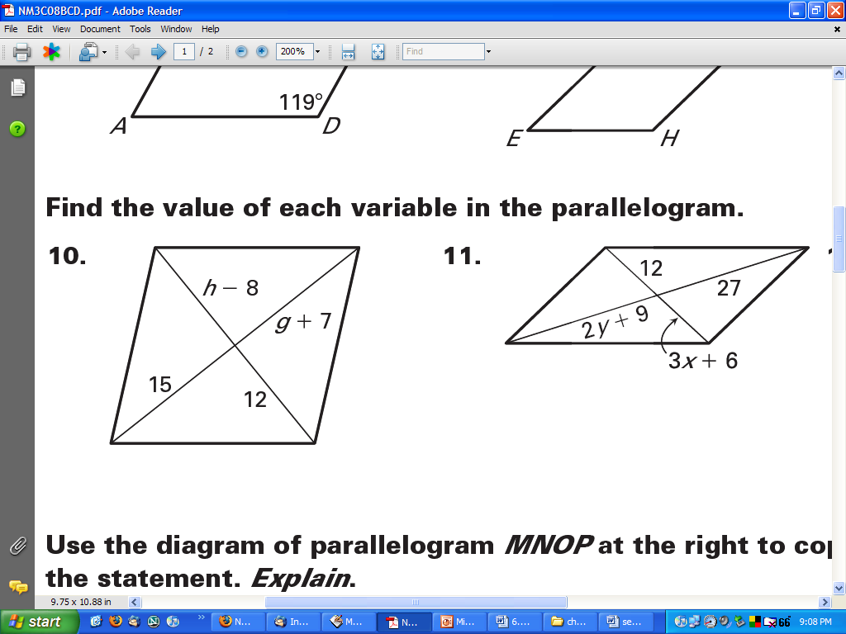

2. Find m∠B and m∠C. 3. Find m∠J and m∠K.
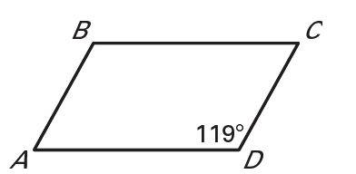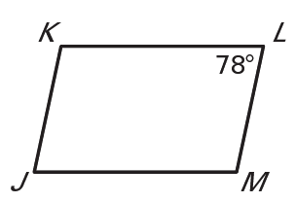

4. Find the value of each variable in the parallelogram.
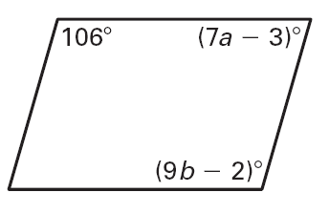
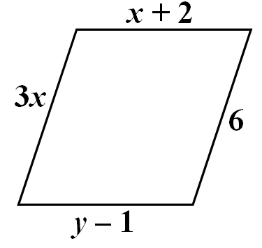

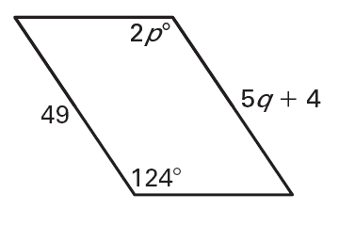

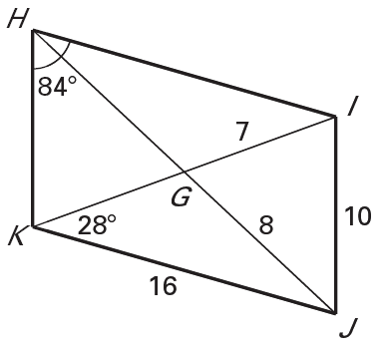
5. 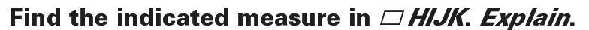

HI = _________ ∠KIH = _________

GH = _________ ∠JIH = _________

KH = _________ ∠KJI = _________

HJ = _________ ∠HKI = _________

If opposite sides of a quadrilateral are ________________, then the quadrilateral is a ________________.

If both pairs of opposite angles are _________________, then the quadrilateral is a _________________.

If consecutive angles are ________________, then the quadrilateral is a ________________.

If the diagonals ____________ each other, then the quadrilateral is a ________________.

NEW!!!!
If one pair of opposite sides are ____________ and ____________, then the quadrilateral is a ________________.

1. What theorem can you use to show the quadrilateral is a parallelogram?

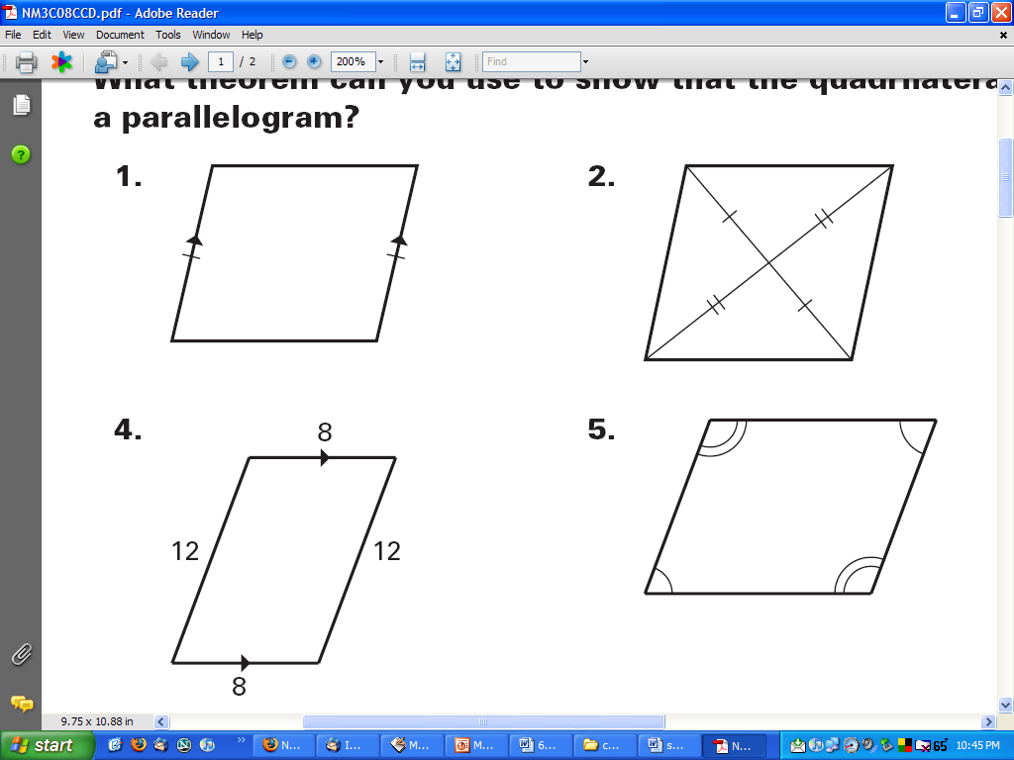

2. Is the quadrilateral a parallelogram? Explain.
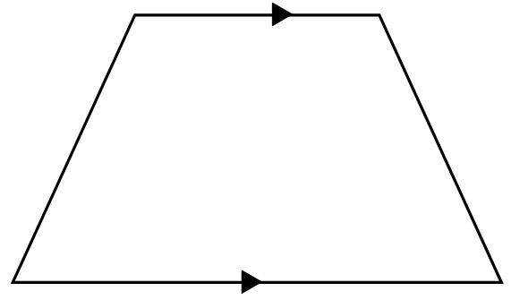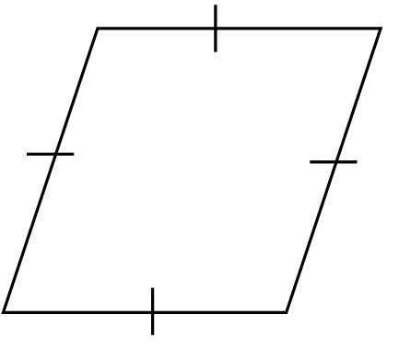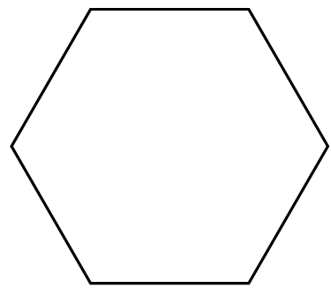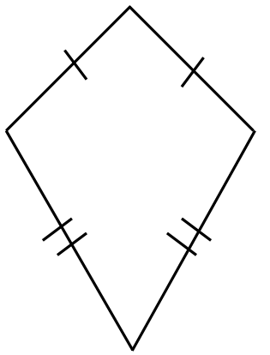

3. What additional information is needed in order to prove that quadrilateral ABCD is a parallelogram?

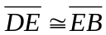

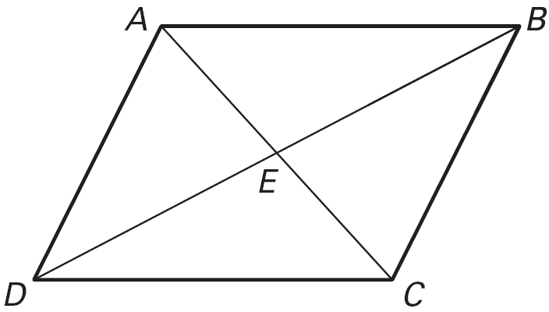

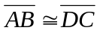
m∠CDA + m∠DAB = 180°

∠DCB ≅ ∠DAB

